Lesson 24 Worksheet: Giving a Memorable Presentation
This worksheet will help you deliver an outstanding presentation by applying creativity to your preparation and enthusiasm to your performance.

1. Get your thoughts in order
(a) What’s your call to action?
Ask yourself:
“What do I want people to do as a result of hearing my talk?”
The answer to this question gives you your call to action.
If you can’t think of a call to action, ask yourself:
“What difference it would make if I didn’t give the presentation?”
If the answer is “not much”, then you should seriously consider not giving it! But hopefully this will help you identify the goal of your presentation, which makes the rest of your preparation a lot easier.

(b) What are your three key points?
Once you have your call to action, ask yourself:
“What three things do the audience need to understand before they can take the desired action?”
Remember, your listeners will not be able to hold more than 3-4 chunks of information in their minds at the same time – so never have more than 4 key points.
Don’t take things for granted – what is obvious to you may well be fresh and surprising to your audience, so think hard about what you know that they don’t. Finding the right angle on the facts will be critical to persuading them of your argument.

(c) Sketching the outline of your presentation
Three key points + call to action = the outline of your presentation
Once you have written these down, stand up and give an unrehearsed two minute version of your presentation (on your own, or if you’re feeling brave, to a friend). You may be pleasantly surprised to discover you can convey the gist of your argument and the call to action after so little work!
This illustrates a key point about presentations – success is not about memorizing every single detail and delivering it word-perfect. It’s about having a basic framework clear in your mind, so that you can talk fluently about the subject without having to refer to notes or slides full of bullet points.
When I coach clients through this activity, they often discover that they know more about the subject than they realized.

(d) Create ‘placemarker’ slides
Remember, slides are optional, but if you’re using them, start off by creating a simple ‘placemarker’ slide with a one or two word summary of each of your three key points. Put this at the beginning and end of the slide deck, and also at the start of each section.
This may seem simplistic, but it will be very helpful to your audience, who are encountering your ideas for the first time.
Here’s another example of a placemarker slide from one of my presentations:
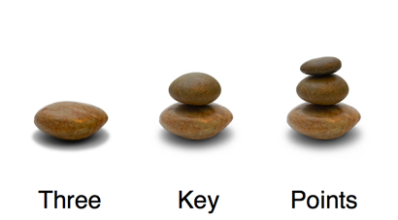
2. Tell a story that matters
(a) Choosing a story
Once you have your three key points + call to action, ask yourself:
Who does this remind me of?
What problems did they face?
How did they solve them?
What was their story?
It’s important to start by asking who? instead of what? because you are looking for a story that illustrates the human drama of the problem and solution you’re presenting.
(b) Everyday or exotic stories?
You have a choice between everyday stories based on the experience of:
- you
- your family and friends
- your colleagues
- your customers
Or exotic stories, based on:
- films or novels
- myths and Legends
- history
- newspapers and TV news
There are no hard and fast rules, as long as the story is relevant to the subject in hand and familiar enough to be meaningful to your audience.
The great thing about everyday stories is that it’s easy for the audience to make a connection between the story and the subject of your presentation. The pitfall is that they may be so familiar the audience stays within their normal frame of reference and doesn’t see the topic in a fresh light.
The great thing about exotic stories is that they are dramatic enough to grab the audience’s attention, and take them out of their normal mindset. The pitfall is that you could get the ‘entertaining, but so what?’ response – so it’s really important to make a clear link between the story and your topic.
E.g. If you tell them that launching their new project is a bit like St George riding out to slay the dragon, you may need to spell out why!

(c) Rehearsing the story
Practise telling the story out loud – both alone and to a sympathetic friend or colleague. Notice which parts get you most animated, and which get the best response from your ‘audience’ – use this to fine-tune the telling of the tale.
Don’t worry about repeating the exact same words each time – you want to leave room for a little spontaneity. And as with the key points and call to action, you may be pleasantly surprised how easily you recall information and arguments associated with the story – stories are great mnemonic devices!

3. Forget confidence, go for enthusiasm
(a) Tap into your enthusiasm for the subject
Ask yourself:
“Why do I care about this?”
“Why should it matter to the audience?”
“What’s the most important thing for them to understand?”
This will help you tap into your natural enthusiasm for the subject – and remember, enthusiasm is infectious. When you’re expressing your enthusiasm, the audience can’t help responding to it.
So if you find yourself getting nervous or worrying about being ‘confident’, bring your attention back to the subject and why you believe it matters to your audience – that will make you less self-conscious and more focused on how to convey the ideas to them.

(b) Maintaining your enthusiasm under pressure
Here’s a series of articles I wrote about maintaining enthusiasm in high-pressure situations. They aren’t specifically about presenting, but the principles and techniques definitely apply to giving presentations, especially to demanding audiences:
Five Reasons Why Enthusiasm Is Better than Confidence: http://www.wishfulthinking.co.uk/2006/11/24/5-reasons-why-enthusiasm-is-better-than-confidence/
How to Maintain Your Enthusiasm When Things Get Tough: http://www.wishfulthinking.co.uk/2007/01/16/how-to-maintain-your-enthusiasm-when-things-get-tough/
Seven Ways to Stop Worrying When You’re Under Pressure: http://www.wishfulthinking.co.uk/2007/01/17/7-ways-to-stop-worrying-when-youre-under-pressure/
Seven Ways to Tap into Enthusiasm: http://www.wishfulthinking.co.uk/2007/02/13/7-ways-to-tap-into-enthusiasm/
4. No more than six words per slide
(a) Create slides with impact
Remember the guidelines from the lesson:
- No bullet points
- No more than six words per slide
- No clipart
- No borders
- No logos (apart from your first and last slides)
And on the positive side:
- One powerful image per slide
- Make sure photos or graphics fill the slide, with no borders
- Make charts crystal clear – illustrate ONE key metric, not every tiny bit of data
- Use few words (if any) in a BIG FONT
For a further treatment of slide design, see this article and Garr Reynolds’ excellent book Presentation Zen:
‘What is good PowerPoint design?’ http://presentationzen.blogs.com/presentationzen/2005/09/whats_good_powe.html

Slide makeover 1
Here’s the original:
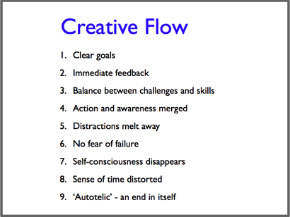
And here’s the revised version:
The second slide doesn’t have the same amount of information, so you might think it wouldn’t be so helpful to me in the middle of a presentation.
But as soon as I see that image, it gives me the feeling I associate with the concept of flow, so I’m able to give an evocative description of the state. I may not cover every single one of the nine points, but I can relax because I know they are in the written summary I’ve prepared for the audience.
Slide makeover 2
In case you’re thinking this is all very well for ‘touchy feely’ concepts, here’s how the same principles apply to presenting data. Starting with a (slightly) exaggerated version of a ‘Death by PowerPoint’ chart slide:
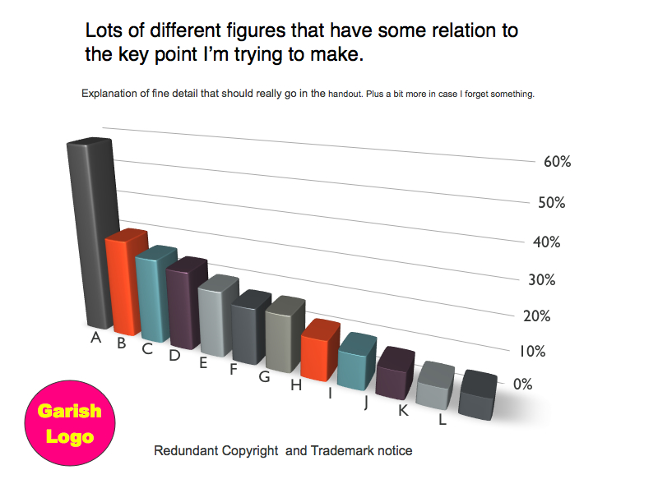
It’s tempting to use a fancy 3D display, but it makes the chart harder to read. And there’s too much small text that should be in the handout. Not to mention that logo…
Here’s the simplified version:
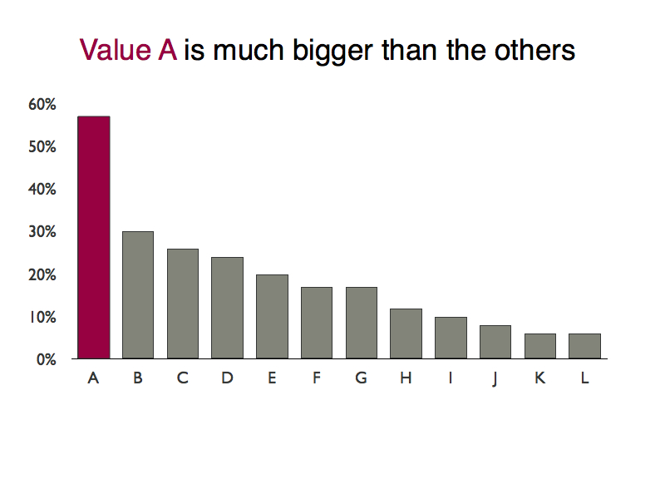
In this slide, the key point jumps out as soon as you look at the slide, making it much easier for the presenter to highlight the dramatic contrast between Value A and the rest.
(b) Create a handout for the audience
Remember, reading a document and listening to a presentation are completely different ways of processing information, so it pays to create a separate handout for the audience to take away. This can take several formats:
- A one-page summary
- An e-book or bound document
- A web page or mini-site
Write out the ideas in the presentation as clearly and simply as you can – using the same 3-4 point structure with the call to action at the end. You should never use this as a script, but I find that writing the document helps me to prepare the presentation – once I’ve thought it all through in writing, I find it easy to speak fluently about the topic, even though I never refer to the written document when I’m on stage.
Another nice effect of having the written summary is that you can tell people they will get the summary so they don’t need to take notes and can relax and focus 100% on the presentation – I’ve had lots of people tell me this makes a big difference to their enjoyment of the presentation and retention of the ideas.

